**CENWP-OD-B 06 July 2022**

**MEMORANDUM FOR THE RECORD**

**SUBJECT: 22BON031 CI LPS Lamprey Mortality**

On 06 July, Bonneville Project Fisheries discovered one lamprey mortality in the Cascades Island LPS rest box #4. The fish was scanned for PIT tags, inspected, and returned to the river.

1. Species – Pacific Lamprey (*Entosphenus tridentatus)*
2. Origin – Unknown
3. Length – Approximately 61 centimeters
4. Marks and tags – None
5. Marks and Injuries found on carcass – None
6. Cause and Time of Death – Unknown
7. Future and Preventative Measures – None

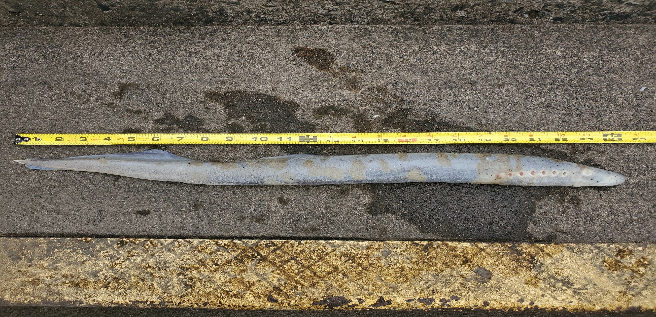

Sincerely,

Bonneville Project Fisheries